Guidelines for Preparation of Research Project Reports

Georgia Department of Transportation

Office of Research

Research and Development Branch

May 2013

Guidelines for Preparation of Research Project Reports

Purpose

These guidelines are for the preparation of research and development (R&D) project reports which are prepared by or for the Georgia Department of Transportation (GDOT). The information contained herein is provided to produce some degree of uniformity in R&D reports and to ensure that applicable GDOT and Federal Highway Administration (FHWA) regulations are followed. This guide will help to promote a more efficient procedure in administering R&D project reports.
The guide consists of two parts. The first part contains general information, and the second part details the format and elements of reports. Progress reports are also required for each research project, but information on these reports is contained in the Georgia DOT Research and Development Manual or on the Georgia Transportation Institute-University Transportation Center (GTI) website at http://www.gti.gatech.edu. Any questions on reports should be directed to the R&D Branch.

Part I – General Information

A. Need for reports

All R&D projects require the preparation, submission, review, and approval of appropriate written reports to document the project's objectives, activities, findings, conclusions, and recommendations and to permit other appropriate persons to understand, evaluate, and duplicate the research project.

B. Type of reports

Reports may be interim, technical, or special in nature, but in any case a final report must be prepared for each project. The type of report to be prepared for each project, along with the due dates, are outlined and discussed in the research project proposal. Please see the Georgia DOT Research and Development Manual (Appendix 3) or the GTI website for R&D proposal guidelines.

- Interim or Phase. An interim report or reports may be required for a long-term project to report on various work phases as they are completed, thus allowing a prompt dissemination and implementation of project results.

- Technical. Technical reports document work of a technical or complex nature which is significant to the project and which merits separate documentation from other reports.

- Special. Special reports may result from informal research work, special research projects, or as an outcome of a unique aspect of a formal research project. In addition, special progress reports may be required for particular projects. These are informal reports desired for quick information purposes and which do not require review or approval. They are also not generally published.

- Final. A final report is required for all projects and should cover activities of the entire project from beginning to end. It should incorporate appropriate data and information from other reports prepared for the project and should be able to stand alone as documentation of all project work.

C. Composition and style of writing

The report should be clear, complete, concise, and written in an understandable style. This is especially important, since many people reading the report may not be familiar with the subject matter or its technical aspects. Aim at providing a report which can be understood and used by all those who may be concerned with its subject.
An introduction should be included in each report to introduce and explain the research project itself and the scope of the report to the reader. A good background statement is important in producing understanding. Tables and figures should be used whenever possible, as they help to present clear and concise information in a summary form, thus eliminating the necessity for lengthy description and explanation in the text. In addition, they make the report more usable in an operational situation and assist in implementing project results. Photographs are helpful for the same reasons and should be used when applicable.
All technical aspects, terms, etc., should be thoroughly explained for the unfamiliar reader. Where lengthy data or information in tables, figures, or text exists, consider placing this information in an appendix to avoid cluttering the text and disrupting the continuity of the report.
Above all, aim at producing a readable report. If project reports are not read, the effectiveness and success of the project itself is greatly reduced.

D. Report submittal, review, approval, printing, and distribution

- Submittal. All reports which are to be published (excluding progress reports) are first prepared in draft form and are submitted in the required number of copies (usually 10, but reference project proposal and/or contract for the exact number) to the R&D Branch for review, comments, and approval by appropriate personnel within GDOT and FHWA, if federal funds are involved. This draft should be reproduced by photocopying or similar means and should be bound with staples or other appropriate binding. The draft should be in a completed form having all the elements of a report.

- Review. The review process normally takes one to two months to complete, depending upon the particular project. Upon completion of this review, comments are returned in writing to the researcher for consideration and incorporation into the final report document.

- Approval. Approval of the report and acceptance for publication are usually also given in an email or letter transmitting review comments to the researcher, but in some cases a second review may be necessary before approval is given. Upon approval of the report and necessary revisions, the report should be prepared for printing as outlined below.

- Printing. The project contract indicates the printing responsibilities, procedures, and number of report copies required for each project. The researcher should provide the R&D Branch with a camera-ready copy of the report with all the text, figures, tables, photographs, etc. being originals, and with a CD-ROM containing two files: (1) the entire report in a single Word file; and (2) the entire report in a single PDF file. Information is given in other parts of this guide on expected content of the camera-ready copy. The report should be assembled ready for printing with no further work required by the R&D Branch. Upon completion of printing, the report original and CD-ROM will be maintained in the files of the R&D Branch.

- Distribution. After printing is complete, the R&D Branch distributes the report to appropriate personnel within and outside GDOT.

Part II – Format and Elements of Report

This section provides guidance relating to the report format and various elements of the report. Any items not covered are left to the discretion of the writer or the R&D Branch should be contacted for guidance or a reference can be consulted such as A Manual for Writers of Term Papers, Theses, and Dissertations by Kate L. Turabian. References are made in the following attached exhibits to illustrate the various items where appropriate.

A. General Elements

- Paper. The paper should be white and 8-1/2 by 11 inches in size. Oversize pages which require folding should be avoided if possible, since they create printing problems. If information cannot be presented legibly on the 8-1/2 x 11 format, consider preparing it on a larger, proportional size format and then reducing to 8-1/2 x 11. Also, since most reports are printed on both sides of a page, use can be made of the two page format by, for example, splitting a figure in the middle and putting part of it on the left page and part on the right page.

- Spacing. All reports should be typed double-spaced.

- Margins. For all pages in the report, margins should be at least 1-¼ inches on each side and 1 inch at the top and bottom, including pages that contain tables, figures, etc. Side margins are particularly important, since printing is usually done using both sides of a page. If adequate margins are not available, the printed material may extend into the binding area.

- Page numbers. All pages in both drafts and final revised versions should be numbered. Pages in the preliminaries or front matter of the report should be numbered with small Roman numerals (i, ii, etc.) at the bottom center of each page. Begin numbering the pages of the remaining portion of the report with the Introduction (or first major heading in the body of the report) and number in the bottom center of the page with Arabic numerals (1, 2, etc.). The page number is usually omitted on the very first page. In numbering the pages themselves, the following guidelines should be followed:

- Draft – Each page should be numbered consecutively following the above rules. All reproduction by photocopying or similar means is done on only one side of a page.

- Final Revised Version – To produce a concise report, reports are sometimes printed using both sides of a page. The writer should consider this printing procedure when preparing the final version of the report (after considering and incorporating all comments from GDOT and FHWA as applicable), which will constitute the “camera-ready” copy that will be used in printing. The foregoing general guide covered in item #4 above should be followed with the addition of the following: (1) all major headings such as the preliminaries or front matter (abstracts, table of contents, list of tables, etc.), chapters, appendices, etc., should begin on the right-hand page, and (2) all right-hand pages should be odd-numbered, and all left-hand pages should be even-numbered (printing tradition). All pages should be numbered in this manner when the camera-ready copy is transmitted to the R&D Branch, so that it can be printed with no further revision. In most cases, it will be necessary to renumber the pages (from those in the draft) and make changes in the table of contents, etc. for two-sided printing.

- Tables and Charts. Tables and charts should be used as needed and should be listed in a list of tables with the table number, the title exactly as shown on the table itself, and the page number. The table number and title are usually placed at the top of the table (see Exhibit A). Each table should be discussed in the text and should appear on the same page or the next page after being mentioned in the text. Table numbers should be consecutive throughout the report. Margins should be the same as on a regular text page (a minimum of 1 ¼ inches on side, 1 inch at top and bottom). If numerous tables are to be presented, consider placing them in an appendix to avoid cluttering the text and perhaps interfering with the reader’s train of thought. If the table must be placed on a page lengthwise, it should be oriented to be read from the right of the report, as shown in Exhibit B.

- Figures. Figures, including photographs, should be used as needed, in accordance with the same guidelines given for Tables and Charts in item #5 above. Figure numbers and titles are placed under the figure. Photographs are useful in reports and should be used whenever appropriate. See Exhibit C.

- Covers. A standardized report cover for Department R&D reports will be provided to the writer upon request, or the writer may choose to use a different cover. In either case, the information contained on the cover, as shown in Exhibit D, must be on the cover.

- Format and Contents

The format and outline of the contents for each report is generally as follows and in the order presented below.

- Preliminaries (Front Matter)
- Inside title page – The inside title page gives appropriate identification of the project and report and is the first page inside the cover. The content of this page varies slightly, depending on whether the project is conducted “in-house” (see Exhibit E) or by contract (see Exhibit F).
- Technical Report Standard Title Page – Each project report should include this Title Page, which is standard for all FHWA-sponsored projects, immediately after the inside title page and preceding the Table of Contents. The Technical Report Standard Title Page includes an abstract of 250 words or less which describes the study in general, including objectives, procedures, and significant findings based on project work. See Exhibit G for an example. A list of key words should be included at the bottom of the Title Page which best describes the report subject matter. The Title Page does not need to be listed in the Table of Contents.
- Table of Contents – A table of contents should be included containing preliminaries (front matter), major divisions of the report, appendices, and references. See Exhibit H.
- List of Tables – See Exhibit I.
- List of Figures – See Exhibit J.
- Executive Summary – An executive summary should be included that summarizes the project objectives, procedures, significant findings, and recommendations for implementation. Suggested length of the executive summary is approximately 1000 words.
- Acknowledgements – This section is optional and is provided to acknowledge the various types of assistance which the researcher has received during the course of the project.
- Other – Other elements may be added as needed.

Body of Report
  - Introduction – Include an introduction to explain the project in general and include brief statements on the background of project, reason for being conducted, objectives, scope, significance, and anticipated results and implementation aspects.
  - Divisions – Following the introduction, the report should be divided into logical divisions depending on the subject matter and should contain information on the study procedure employed, findings, conclusions, and recommendations (including suggested implementation), although the chapters of headings need not bear these exact titles.
  - List of references or bibliography – An appropriate listing should be given for publications suggested for reference and/or consulted during the course of the project. See Exhibit K.
  - Appendices – Include in the appendices any material which is not appropriate for inclusion in the text due to length, technical nature, etc. See Exhibit L for titling guide.
EXHIBIT A

TABLE 1
Title of Table

Notes:
(1) Type table number and title at top of page.
(2) Maintain minimum margins of 1-¼ inch on sides and 1 inch at top and bottom.

EXHIBIT B

TABLE 2

Title of Table

Note: When tables (or figures) are oriented lengthwise on paper, always prepare so as to be read from
the right side, as shown here.

EXHIBIT C

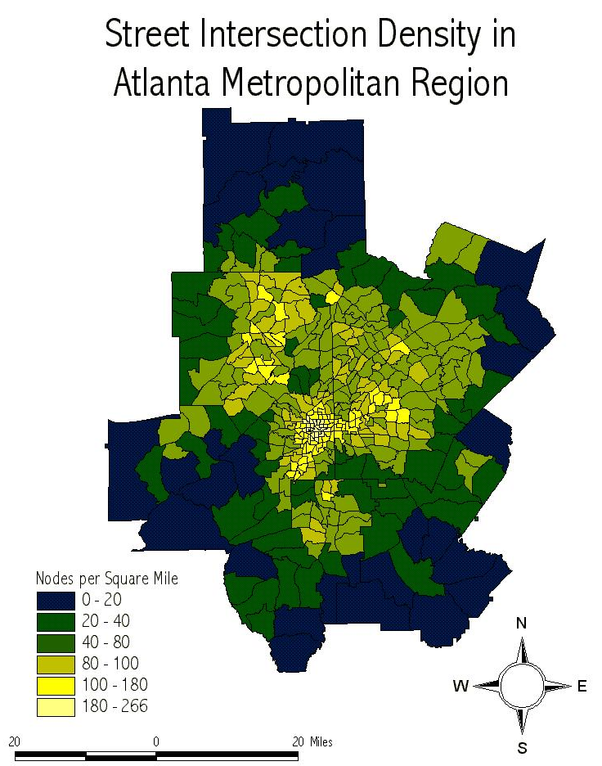

FIGURE 1

Title of Figure

Notes:

(1) Type figure number and title underneath figure.
(2) Maintain minimum margins of 1-¼ inch on sides and 1 inch at top and bottom.

EXHIBIT D

GEORGIA DOT RESEARCH PROJECT 2013

FINAL REPORT

DESIGN AND OPERATION OF AN ELECTRONIC SCREENING SYSTEM FOR COMMERCIAL
VEHICLES IN GEORGIA

OFFICE OF RESEARCH
RESEARCH & DEVELOPMENT BRANCH

EXHIBIT E

(Example Title Page—to be used by units of Georgia
Department of Transportation conducting research)

GDOT Research Project No. xxxx

Title of Project (only if different from Title of Report)

Final (or Interim or Technical) Report

TITLE OF REPORT IN CAPITALS

By
Name
Title

Unit of Department Conducting Research
Georgia Department of Transportation

In cooperation with

U.S. Department of Transportation
Federal Highway Administration

Month, Year

The contents of this report reflect the views of the author(s) who is (are) responsible for the facts and the accuracy of the data presented herein. The contents do not necessarily reflect the official views or policies of the Georgia Department of Transportation or the Federal Highway Administration. This report does not constitute a standard, specification, or regulation.

EXHIBIT F

(Example Title Page—to be used by contractors
conducting research for the Georgia Department
of Transportation)

GDOT Research Project No. xxxx

Title of Project (only if different from Title of Report)

Final (or Interim or Technical) Report

TITLE OF REPORT IN CAPITALS

By
Name
Title

Name of Contractor

Contract with

Georgia Department of Transportation

In cooperation with

U.S. Department of Transportation
Federal Highway Administration

Month, Year

The contents of this report reflect the views of the author(s) who is (are) responsible for the facts and the accuracy of the data presented herein. The contents do not necessarily reflect the official views or policies of the Georgia Department of Transportation or the Federal Highway Administration. This report does not constitute a standard, specification, or regulation.

EXHIBIT G

TECHNICAL REPORT STANDARD TITLE PAGE
1.Report No.:  FHWA-GA-07-2037 |  | 2. Government Accession No.: |  |  | 3. Recipient's Catalog No.:
4. Title and Subtitle:  Evaluation of the Use of Reclaimed Asphalt Pavement in Stone Matrix Asphalt Mixtures |  |  | 5. Report Date:  August 2007
 |  |  | 6. Performing Organization Code:
7. Author(s):  Donald E. Watson, P.E. |  |  | 8. Performing Organ. Report No.:  2037
9. Performing Organization Name and Address:  National Center for Asphalt Technology  Auburn University  277 Technology Parkway  Auburn, AL 36830 |  |  | 10. Work Unit No.:
11. Contract or Grant No.:
SPR00-0006-00(357)
12. Sponsoring Agency Name and Address:  Georgia Department of Transportation  Office of Research  15 Kennedy Drive  Forest Park, GA 30297-2534 |  |  | 13. Type of Report and Period Covered:  Final; August 2004-August 2007
 |  |  | 14. Sponsoring Agency Code:
15. Supplementary Notes:
Prepared in cooperation with the U.S. Department of Transportation, Federal Highway Administration.
16. Abstract:
The objectives of this study were to evaluate the effect of various RAP types and proportions on combined material and performance properties of SMA mixtures. Some of the pertinent conclusions from this study are:
- The addition of RAP may be beneficial for resistance to moisture damage, and adversely affects only the fatigue performance of the mixtures, especially at high strain levels.
- Adding RAP up to 30% had little effect on the low temperature PG properties.
- It is recommended that GDOT specifications be modified to allow up to 20% RAP in SMA mixtures with no change in virgin binder grade. Mixtures will still need to meet the same gradation, volumetric, and performance criteria as virgin mixtures.
- RAP proportions higher than 20% may be allowed, but the virgin binder grade may need to be reduced to improve fatigue performance properties.
17. Key Words:  Stone Matrix Asphalt, reclaimed asphalt pavement, tensile strength, fatigue, rutting, creep compliance |  |  |  | 18. Distribution Statement:
19. Security Classification (of this report):  Unclassified | 20. Security Classification (of this page):  Unclassified |  |  | 21. Number of Pages:  65 |  | 22. Price:
Form DOT 1700.7 (8-69)
EXHIBIT H

TABLE OF CONTENTS

Page

LIST OF TABLES X

LIST OF FIGURES X

EXECUTIVE SUMMARY X

ACKNOWLEDGMENTS X

*INTRODUCTION X

*PROCEDURE X

*FINDINGS X

*CONCLUSIONS X

*RECOMMENDATIONS X

REFERENCES X

APPENDICES

Appendix A—Title X

Appendix B—Title X

*These headings are presented only as a guide for the type of information to be contained in a report. Specific headings should be developed for each individual report.
EXHIBIT I

LIST OF TABLES

Table Page

1. Title of Table 1 (as it appears on table in body of report)……….…………………..x

2. Title of Table 2………………………………………………………….………………………………..x

3. Title of Table 3…………………………………………………………………………………………...x

4. etc. ……………………………………………………………………..…………………………………....x
EXHIBIT J

LIST OF FIGURES

Figure Page

1. Title of Figure 1 (as it appears on figure in body of report)……….……………..…x

2. Title of Figure 2.………………………………………………………….……………………………..x

3. Title of Figure 3.………………………………………………………………………………………...x

4. etc. ……………………………………………………………………………………………………………x
EXHIBIT K

Note: If a list of references or bibliography is included, use the standard format as illustrated below. A good reference is A Manual for Writers of Term Papers, Theses, and Dissertations by Kate L. Turabian.

REFERENCES

1. National Association of Motor Bus Owners, Bus Facts, 31st edition, p. 6.

2. “Financing of Georgia’s Highway, Road, and Street Program: Summary Report, Wilbur Smith and Associates, Dec. 1998.

3. Bates, J.W., “Development and Use of a Statewide Origin and Destination Data Bank”, GHD Research Assistant Project 2-99, State Highway Department of Georgia, 1994.

4. Ibid.

5. Bates, J.W., “Comprehensive Planning for Rural Regions—a Case Study”, Research Assistance Project No. 2-94, State Highway Department of Georgia, 1994.

6. Bates, J.W., “Development of Models for Regional Transportation Studies—Project Design”, Research Assistance Project No. 2-96, State Highway Department of Georgia, 1996.

7. Arrillage, B., “Development of a State-wide Traffic Model for the State of Georgia—Draft Literature Review”, GHD Research Project No. 9101, State Department of Georgia, 1991.

8. Bates, J.W., “Development and use of a Statewide Origin and Destination Data Bank”, op. cit.

9. Ibid.

10. Dixon, W.J., “Biomedical Computer Programs”, University of California Press, Los Angles, 1992.

11. Draper, N.R. and Smith, H., Applied Regression Analysis, John Wiley and Sons, Inc., New York, 1993.

12. County and City Data Book, Bureau of the Census, 1995.

13. Draper, N.R. and Smith, H., op. cit., p. 86.
EXHIBIT L

Appendix A
Title of Appendix

Note: If appendices are used, the appendix designation and title may be placed on one page, with the appendix material beginning on next right-hand page. Alternately, the appendix designation, title, and material can be contained on the same

